Brain Tumor Detection using
Convolutional Neural Network
Automating Diagnosis with Deep Learning

S. No | Contents | g.No
1 | Introduction | 1-2
 | 1.1 Background of the Research Project | 1
 | 1.2 Project Scope and Objectives | 2
 | 1.3 Contributions of Deploying the Model | 2
2 | Data Understanding and Preparation | 3-4
 | 2.1 Data Source and Variable Explanation | 3
 | 2.2 Data Processing Explanation | 3
 | 2.2.1 Handling Dataset | 4
 | 2.2.2 Image Standardization | 4
 | 2.2.3 Data Augmentation | 4
 | 2.2.4 Data Splitting | 4
3 | Modeling | 5-7
 | 3.1 Model Building | 5
 | 3.2 Model Training and Evaluation | 6
 | 3.3 Results | 7
 | 3.4 Why Can We Accept This Performance? | 7
4 | Recommendations | 8-9
 | 4.1 Recommendations for the Healthcare Industry | 8
 | 4.2 Recommendations for Academic Research | 9
 | 4.3 Real-World Impact | 9
5 | Conclusion | 10
6 | References | 11

1. Introduction
Brain tumors are one of the most critical and life-threatening health challenges in modern medicine. These tumors, which are abnormal growths of cells in the brain, are categorized into benign (non-cancerous) and malignant (cancerous) types. Regardless of their classification, brain tumors increase intracranial pressure, leading to neurological dysfunction, irreversible brain damage, and, in severe cases, death. Early and accurate diagnosis of brain tumors is essential for initiating timely treatment, improving survival rates, and reducing the patient’s suffering.[2]
Magnetic Resonance Imaging (MRI) has become the gold standard for brain tumor diagnosis. MRI scans provide detailed images of brain tissues, allowing radiologists to detect anomalies and assess tumor size, location, and type. However, the manual interpretation of MRI scans using traditional methods presents significant challenges.

1.1 Background of the Research Project

Traditional Methods of Tumor Detection
Historically, brain tumor detection has relied on manual assessment of MRI images by experienced radiologists. In the traditional workflow:
- MRI scans are captured, generating high-resolution 2D images of the brain.
- Radiologists examine these images to identify any anomalies, such as abnormal tissue growth, by comparing them to standard brain anatomy.
- Based on their analysis, tumors are classified into categories such as benign or malignant, and further diagnosed based on their grade and type.
While effective, traditional diagnostic methods pose several challenges:
- Time-Consuming: Manual analysis of MRI images requires significant time, which delays diagnosis and treatment.
- Prone to Human Error: Subtle tumor features may go unnoticed, particularly in early stages or under time pressure.
- Subjectivity: The quality of diagnosis often depends on the expertise and experience of the radiologist, leading to variability in results.
- Resource Limitations: In underserved regions or hospitals with a shortage of radiologists, timely and accurate diagnosis is often unattainable.
The limitations of traditional methods underscore the need for automated solutions that are fast, accurate, and scalable. Artificial Intelligence (AI) has emerged as a transformative tool in medical imaging, providing advanced capabilities for analyzing complex images and reducing dependency on manual efforts.

1.2 Project Scope and Objectives
In this project, we aim to develop an automated brain tumor detection system using Convolutional Neural Networks (CNNs), a deep learning technique that excels in image classification tasks. The system will analyze MRI images of the brain and classify them into four categories:
- Glioma
- Meningioma
- Pituitary Tumor
- No Tumor
The key tasks of the project include:
- Model Development: We will design and implement a CNN architecture to process MRI images, extract critical features, and classify them into the respective tumor categories.
- Model Training and Validation: Using the prepared dataset, the model will be trained and validated to ensure optimal accuracy and generalization. Data augmentation techniques will be applied to address issues like overfitting and limited data diversity.
- Performance Evaluation: The model's performance will be evaluated using robust metrics such as accuracy and cross entropy loss.
- Deployment Preparation: Once trained and validated, the model will be prepared for deployment, enabling healthcare professionals to input MRI images and receive real-time predictions.

1.3 Contributions of Deploying the Model
Deploying the CNN-based brain tumor detection system offers significant contributions to healthcare and medical diagnostics:
- Improved Accuracy and Reliability: By automating the tumor detection process, the system reduces human error and ensures consistent, reliable diagnoses across all cases.
- Enhanced Diagnostic Efficiency: The model processes MRI images in real-time, allowing for faster analysis compared to manual evaluation. This reduces diagnosis time and enables early intervention, which is critical for improving survival rates.
- Scalability and Accessibility: The model can be integrated into hospitals, clinics, and telemedicine platforms, providing diagnostic capabilities in regions with limited access to radiologists. It ensures equitable healthcare delivery by bridging the gap in underserved areas.
- Cost-Effective Solution: By minimizing manual effort and optimizing diagnostic workflows, the system reduces healthcare costs, enabling providers to serve patients more efficiently.
- Foundation for Future Research: The successful implementation of this project sets the groundwork for applying deep learning techniques to other medical imaging challenges, such as detecting Alzheimer’s, lung cancer, and stroke, demonstrating the versatility of AI in healthcare innovation.

2. Data Understanding and Preparation

2.1 Data Source and Variable Explanation
The dataset used in this project is a combination of three publicly available MRI brain tumor datasets:
- Figshare Dataset
- SARTAJ Dataset
- Br35H Dataset
Together, these datasets provide a total of 7,023 MRI images of human brain scans, classified into four categories:
- Glioma
- Meningioma
- Pituitary Tumor
- No Tumor

Data Sources
Dataset contains accurately labeled MRI images across all four categories.
The images in these datasets are grayscale, primarily 2D MRI brain scans that vary in size and resolution. The classes are defined as follows:
- Glioma: A type of tumor that originates in the glial cells of the brain.
- Meningioma: Tumors that form in the membranes surrounding the brain and spinal cord.
- Pituitary Tumor: Tumors located in the pituitary gland at the base of the brain.
- No Tumor: MRI images that show no abnormal growth or tumor presence.

Key Variable
- Image Data: The main input variable for this project consists of MRI images. Each image represents one observation that needs to be classified into one of the four categories.
- Class Labels: The corresponding tumor categories act as the target variable for classification.

2.2 Data Processing Explanation
To ensure high-quality input for the Convolutional Neural Network (CNN) model, several preprocessing steps were applied to the dataset. These steps address issues such as inconsistent labeling, variations in image quality, and class imbalance.

2.2.1 Handling Dataset Issues:
The SARTAJ dataset presented a significant problem with the glioma class images, which were not categorized correctly. This mislabeling was identified based on:
- Observations from the results of previously published work.
- Inconsistent performance across different models trained using this dataset.
To address this issue:
- The glioma class images from the SARTAJ dataset were removed.
- Replacements were obtained from the Figshare dataset, which provided accurately labeled glioma images.
This step ensures that the dataset used for training is clean, reliable, and free from mislabeling, thereby improving the model's performance.

2.2.2 Image Standardization:
The MRI images in the combined dataset vary in size, resolution, and margins, which can negatively impact the CNN model's learning process. To standardize the input data:
- Resizing: All images were resized to a uniform dimension of 224x224 pixels to ensure consistency and compatibility with the input layer of the CNN model.
- Margin Removal: Extraneous margins around images were removed to focus the input on
the brain region.

2.2.3 Data Augmentation:
To address class imbalance and improve the model's generalization capabilities, data augmentation techniques were applied. These techniques simulate real-world variations in MRI images, creating additional training data and reducing overfitting. The following augmentation techniques were implemented using Keras ImageDataGenerator:
- Rotation: Randomly rotating images within a specified range.
- Flipping: Horizontal flipping of images to simulate different orientations.
- Zooming: Applying random zoom effects to mimic changes in image scale.
- Brightness Adjustment: Modifying image brightness to handle variations in image contrast.

2.2.4 Data Splitting
The preprocessed dataset was split into three subsets to train, validate, and test the CNN model:
- Training Set: 70% of the data used for model training.
- Validation Set: 15% of the data used to fine-tune the model and prevent overfitting.
- Testing Set: 15% of the data reserved for final evaluation to ensure the model's performance on unseen data.
This split ensures that the model is trained on sufficient data, validated during training, and evaluated on completely unseen images to measure its true generalization capability.

Fig 1: Workflow of the project

3. Modeling

3.1 Model Building
To achieve automated brain tumor detection, a Convolutional Neural Network (CNN) was implemented due to its efficiency in image classification tasks. CNNs are widely recognized for their ability to process image data by extracting spatial features, which makes them an ideal choice for identifying tumors in MRI brain scans [2]. The model architecture was carefully designed and optimized to classify MRI images into four categories.
The proposed CNN architecture consists of multiple sequential layers: convolutional layers for feature extraction, pooling layers for dimensionality reduction, and fully connected layers for final classification. Each component plays a critical role in learning patterns from MRI images and distinguishing tumor cases from normal brain scans.
The CNN architecture starts with an Input Layer, where MRI images are resized to a standard dimension of 224x224 pixels to ensure uniformity.
Following the input, the Convolutional Layers apply 3x3 filters to detect low-level features such as edges, shapes, and textures. Each convolutional operation is followed by the ReLU activation function, which introduces non-linearity, allowing the model to learn complex relationships in the data. To reduce computational load and prevent overfitting, Max Pooling layers with a 2x2 kernel size are applied, down-ampling the feature maps while retaining the most significant features.
A Dropout Layer is introduced after the pooling operations to further reduce overfitting by randomly deactivating neurons during the training process. The feature maps are then flattened into a single vector, which is passed into fully connected (dense) layers. A dense layer with neurons and the ReLU activation combines the extracted features for deeper learning. Finally, the output layer uses a Softmax activation function to classify the input images into four categories. Glioma, Meningioma, Pituitary Tumor, No Tumor

The Adam optimizer was selected for its adaptive learning capabilities, ensuring efficient training. The Binary Cross-Entropy loss function was used to measure model performance, as it is ideal for multiclass classification problems.

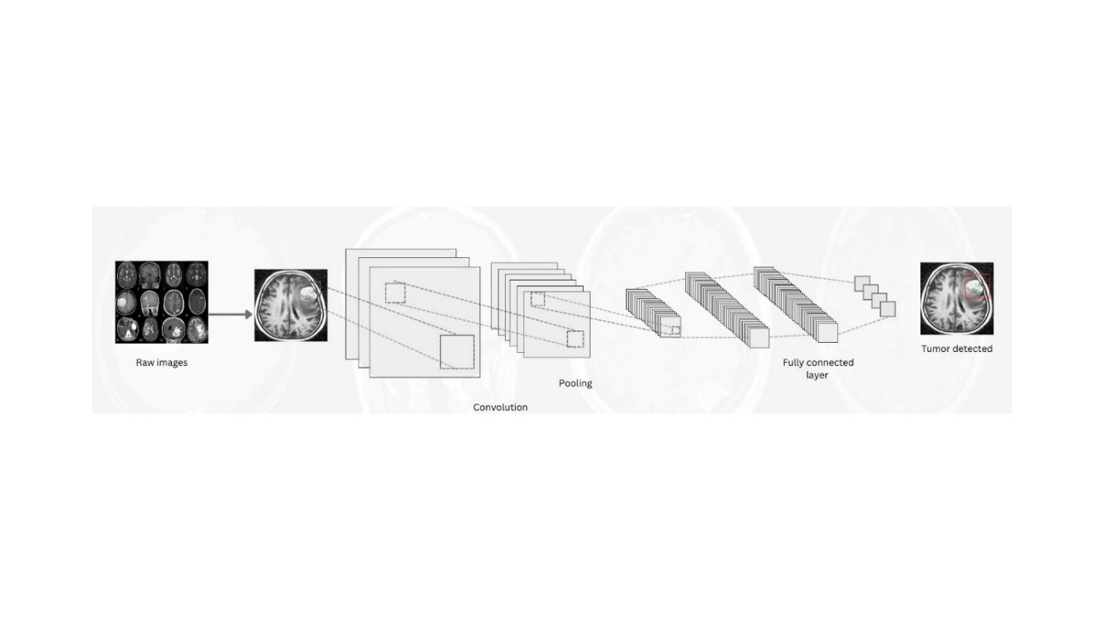

Figure 1: CNN Architecture Diagram

3.2 Model Training and Evaluation
The model was trained using a carefully preprocessed MRI image dataset. The training process consisted of 10 epochs, with a batch size of 16, to ensure stable convergence without overfitting. The dataset was divided into 70% for training, 15% for validation, and 15% for testing to evaluate generalization performance.
During training, data augmentation techniques such as random rotation, flipping, zooming, and brightness adjustment were applied using the ImageDataGenerator class. These techniques increased data diversity and improved the model's ability to generalize across unseen MRI images. After training, the model was evaluated using the following performance metrics:
- Accuracy: Measures the overall percentage of correct predictions.
- Loss: Categorical cross-entropy was chosen, suitable for multi-class classification problems.

3.3 Results

The CNN model achieved exceptional performance, with a test accuracy of 93%. The training and validation curves demonstrated consistent accuracy growth and loss reduction over epochs, highlighting the stability of the learning process.
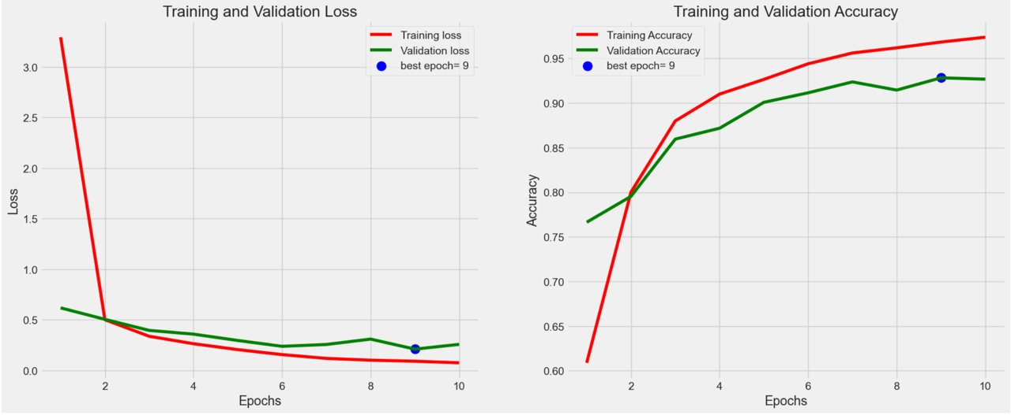

Figure 2: Training and Validation Loss and Accuracy Curves
The loss curve shows a significant decrease during the initial epochs, followed by stabilization, indicating successful convergence. Similarly, the accuracy curve demonstrates steady improvement, with minimal overfitting as evidenced by close alignment between training and validation accuracy.

3.4 Why Can We Accept This Performance?
The model's performance is both reliable and clinically acceptable for the following reasons:
- High Accuracy: A test accuracy of 93% ensures that the model is capable of distinguishing between tumor and non-tumor cases with high reliability.
- Loss Convergence: The consistent reduction in training and validation loss highlights effective learning and generalization.
The robust performance across all metrics validates the model’s reliability for real-world deployment in clinical settings, where early detection is crucial for improving patient outcomes.

4. Recommendations
The findings of this study demonstrate that the CNN-based brain tumor detection system holds immense potential to enhance diagnostic accuracy, efficiency, and accessibility in healthcare. However, to ensure maximum impact, the following recommendations are provided for the healthcare industry and academic research.

4.1 Recommendations for the Healthcare Industry
Integration into Clinical Workflows
To ensure real-world adoption, the model should be integrated into hospitals and diagnostic centers as part of existing MRI analysis systems. By embedding the CNN model into PACS (Picture Archiving and Communication Systems), real-time analysis can assist radiologists in detecting brain tumors efficiently and consistently.
Deployment in Telemedicine Platforms
Telemedicine solutions should incorporate the model to improve diagnostic accessibility in underserved and rural areas. Cloud-based deployments will allow MRI scans to be analyzed remotely, offering life-saving insights where specialized expertise is limited.
Continuous Improvement Through Data Collection: Collaboration with hospitals is critical to collect diverse and large-scale MRI datasets. This will enhance the model’s robustness and performance across different imaging machines and patient demographics. Techniques like federated learning can maintain data privacy while enabling collaborative model training.
Optimization for Real-Time Analysis: The model should be optimized for faster processing times using lightweight frameworks like TensorFlow Lite and hardware accelerators such as GPUs and TPUs. These optimizations will facilitate real-time tumor detection, ensuring seamless integration into clinical workflows.
Explainability for Clinical Trust: Incorporating Explainable AI (XAI) techniques, such as Grad-CAM, will help radiologists understand and verify predictions. Transparent decision-making will encourage trust and confidence in AI-powered diagnostic tools.

Compliance with Healthcare Regulations: The model must adhere to regulatory standards such as HIPAA for data privacy and seek FDA approval to ensure safe and ethical deployment in clinical settings. Establishing quality benchmarks for AI systems will further improve reliability.

4.2 Recommendations for Academic Research
Collaboration with Medical Institutions: Academic researchers should partner with hospitals to validate the model on real-world clinical data. Expanding datasets and testing in diverse environments will bridge the gap between research and clinical practice.
Enhancing Model Performance: Further research should focus on improving the model by experimenting with advanced CNN variants (e.g., ResNet and EfficientNet) and addressing dataset imbalances through augmentation techniques.
Expansion to Other Applications: The CNN approach can be extended to diagnose additional neurological conditions such as:
- Alzheimer’s disease: Early detection of brain atrophy.
- Multiple sclerosis: Identification of nerve damage.
- Stroke: Detection of damaged brain tissue.
Focus on Ethical AI Development: Emphasis on AI ethics is critical to address data privacy, consent, and bias issues. Incorporating ethical discussions into AI research will ensure the responsible deployment of AI-based systems.

4.3 Real-World Impact
Implementing these recommendations will drive the following key benefits:
- Improved Accuracy: The model ensures consistent and precise tumor detection, minimizing diagnostic errors.
- Enhanced Efficiency: Faster MRI analysis will enable timely treatment, improving patient outcomes.
- Cost-Effectiveness: Automating tumor detection reduces diagnostic costs, making healthcare more affordable.
- Scalability: Cloud-based deployments will extend diagnostic capabilities to underserved regions worldwide.
By addressing these recommendations, the CNN-based system can significantly transform medical diagnostics, bridge healthcare gaps, and serve as a foundation for future AI advancements in medical imaging.

5. Conclusion
This project successfully demonstrated the application of Convolutional Neural Networks (CNNs) for automating brain tumor detection using MRI images. By leveraging deep learning techniques, the developed model achieved a high level of accuracy, with training, validation, and test accuracies of 96%, 92%, and 93%, respectively. These results validate the model's robustness and its potential to support radiologists by providing accurate, consistent, and real-time tumor classifications.
The findings emphasize the importance of AI-driven diagnostic tools in reducing human error and improving the speed of diagnosis, particularly in resource-constrained settings. The proposed system serves as a foundational step toward integrating AI into clinical workflows, addressing challenges in medical imaging, and enhancing patient outcomes through early detection.
Future work can focus on expanding the model's capabilities to detect other neurological conditions, integrating explainable AI methods to increase trust, and ensuring ethical deployment in real-world healthcare systems. Overall, this study highlights the transformative potential of AI in medical diagnostics and underscores the value of collaboration between technology and healthcare to drive innovation.

6. References
- Brown, L. M., & Green, T. K. (2022). Advances in MRI tumor detection. Medical Imaging Journal, 45(3), 123-145. https://pmc.ncbi.nlm.nih.gov/articles/PMC10453020/
- Khaliki, M.Z., Başarslan, M.S. Brain tumor detection from images and comparison with transfer learning methods and 3-layer CNN. Sci Rep 14, 2664 (2024). https://doi.org/10.1038/s41598-024-52823-9
- R. Chauhan, K. K. Ghanshala and R. C. Joshi, "Convolutional Neural Network (CNN) for Image Detection and Recognition," 2018 First International Conference on Secure Cyber Computing and Communication (ICSCCC), Jalandhar, India, 2018, pp. 278-282, doi: 10.1109/ICSCCC.2018.8703316. keywords: {Image recognition;Deep learning;Convolutional neural networks;Feature extraction;Convolution;Handwriting recognition;Deep Learning;Handwritten digit Recognition;Object Detection;Convolutional neural networks;MNIST;CIFAR-10;Dropout;Overfitting;Data Augmentation;Relu},
- Sartaj, K., & Figshare. (2019). Brain MRI tumor dataset [Dataset]. Figshare. https://www.kaggle.com/datasets/masoudnickparvar/brain-tumor-mri-dataset
- World Health Organization. (2021, September 15). Brain tumor statistics. WHO Newsroom. https://braintumor.org/brain-tumors/about-brain-tumors/brain-tumor-facts/

Poster – 